**Platform as a Service (PAAS)**

* If we use IAAS to deploy the applications, it would look as shown below 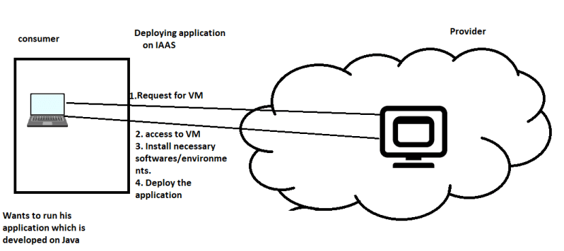
* In PAAS ready-made platforms for running technologies like java, .net, node, python etc are made available. Users can directly request those environments. If you want customizations, some providers give the options and all providers support docker as a platform.
* Deploying application on PAAS is as shown below 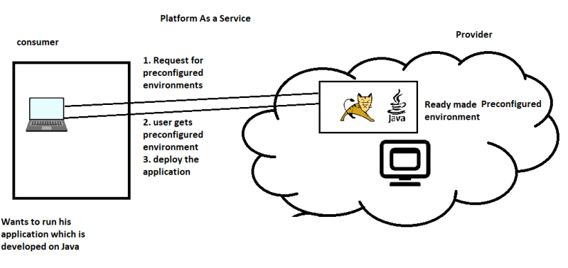
* Popular PAAS (Other Than Google, AWS, Azure)
  + Pivotal Cloud Foundry
  + IBM Bluemix
* Used by:
  + Organizations building applications

**Software-as-a-Service**

* Generally used for end users.
* Scenario: Your organization xyz has a Payroll software which they run on-premise, Now your organization has decided to run Payroll on Cloud to avoid Hardware Maintenance, Let look at possible options
  + Create VM using IAAS and install/configure the necessary environments and deploy the application
  + Deploy the application using PAAS if the necessary platform is available.
  + If the software is already available as a Service then directly create it. 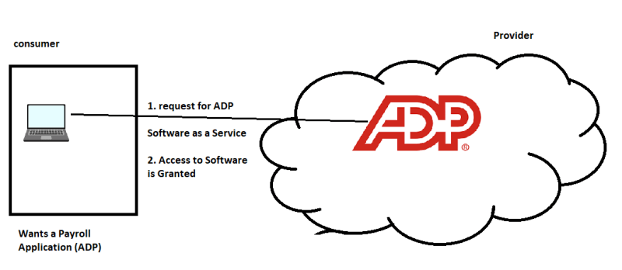

**Cloud Deployment Models**

* The following Deployment Models are popular
  + Public Cloud
  + Private Cloud
  + Hybrid Cloud
* Public Cloud:
  + It is a publicly accesible cloud environment owned by a third-party provider
  + Provider is responsible for creation of the resources requested by user.
  + Popular Players
    - Amazon (AWS)
    - Microsoft (Azure)
    - Google (GCE)
    - Salesforce
  + Public Clouds Provider can use one or all of the delivery models
  + In majority of the cases Public Clouds are multi-tenant (They do support single-tenancy)
* Private Cloud:
  + Generally Owned by a Single Organization
  + Created for using Cloud computing technology for providing IT resources to the organization
  + In this same organization is consumer and provider
  + Popular Products for Private Cloud
    - Open Stack
    - Azure Stack
* Hybrid Cloud:
  + Cloud environment which is comprimised of two or more deployment models